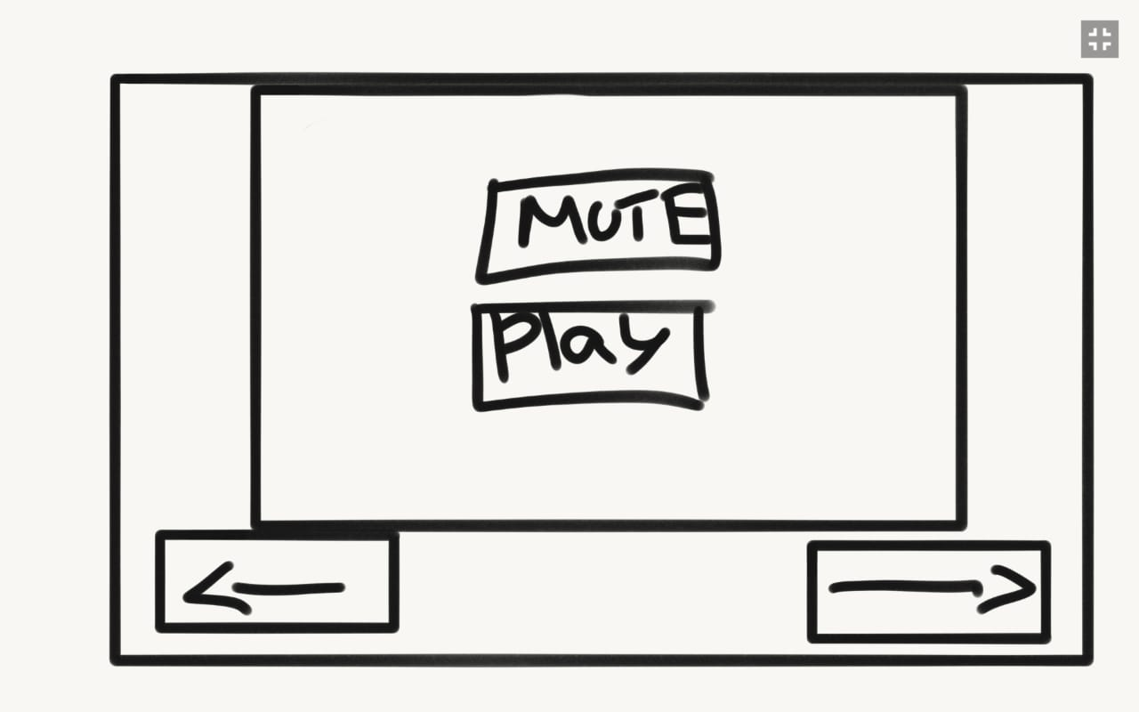Game Design Document

Fill up the Following document

1. Write the title of your project.

Travel all way

1. What is the goal of the game?

The player has to travel(complete) all the destination(levels).

1. Write a brief story of your game?

The player has to travel (complete) the entire destination (levels).

In the game the player is an enthusiastic traveler. The character animation keeps on changing with level up. Each player has three lives.

1. Which are the playing characters of this game?

* Playing characters are the ones which respond to the user based on the input from the user
* Cars, monkeys, dinos, wizards etc, are the playing characters in the game.

|  |  |  |
| --- | --- | --- |
| Number | Character Name | What can this character do? |
| 1 | Rebecca | 1st traveler |
| 2 | Ilyssa | 2nd traveler |
| 3 | James | 3rd traveler |
| 4 | Adam | 4th traveler |
| 5 | Alan | 5th traveler |
| 6 | Jaiden | 6th traveler |
| 7 | Ami | 7th traveler |
| 8 | Maaz | 8th traveler |

1. Which are the Non Playing Characters of this game?

* Non Playing characters are the ones which don't have an action or a behavior when the user interacts with the game.
* Hurdles, stones, bananas, coins, etc are non playing characters in the game.

|  |  |  |
| --- | --- | --- |
| Number | Character Name | What can this character do? |
| 1 | Coins | On collecting them they can buy food or choose characters |
| 2 | Rocks | If they hit the rocks one life will decrease |
| 3 | Manhole | If you fall in manhole one life will decrease |
| 4 |  |  |
| 5 |  |  |
| 6 |  |  |
| 7 |  |  |
| 8 |  |  |

Draw your imagination of this game. What does this game look like?

* Draw the game either on your computer or on paper,
* Add images of scenes of the game to show each of the playing and non-playing characters at least once.

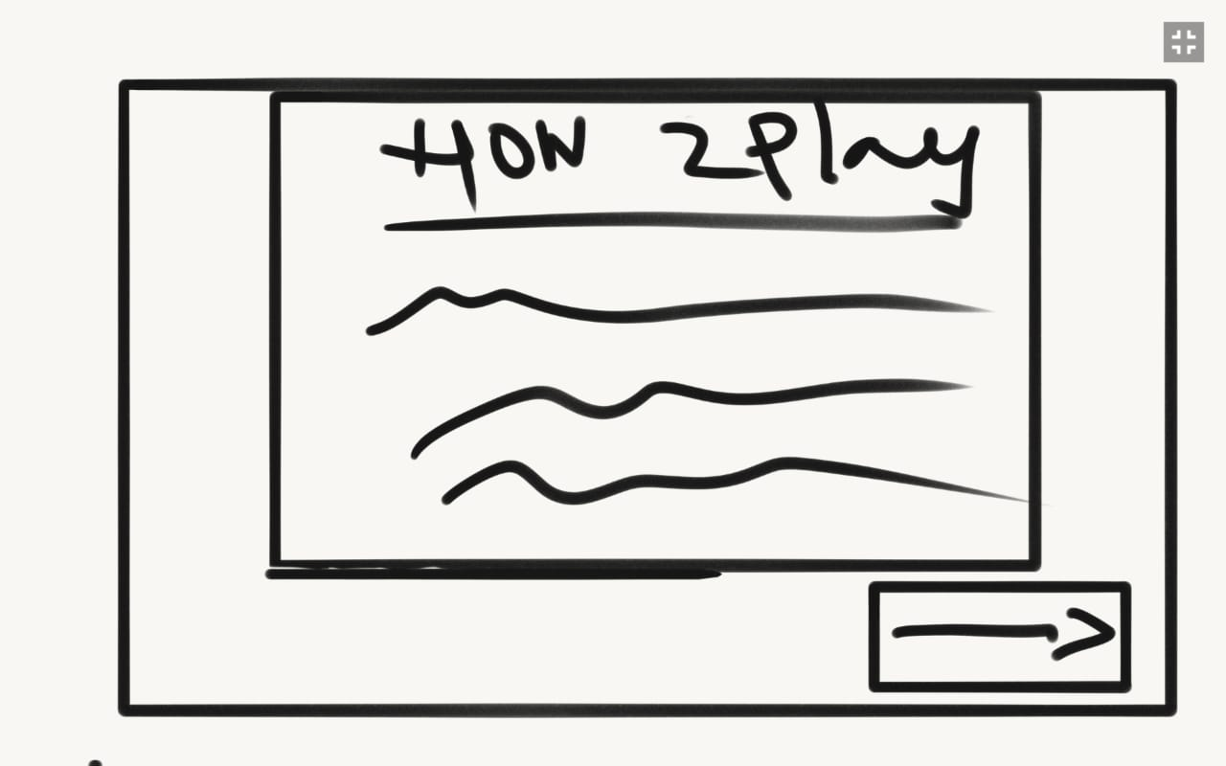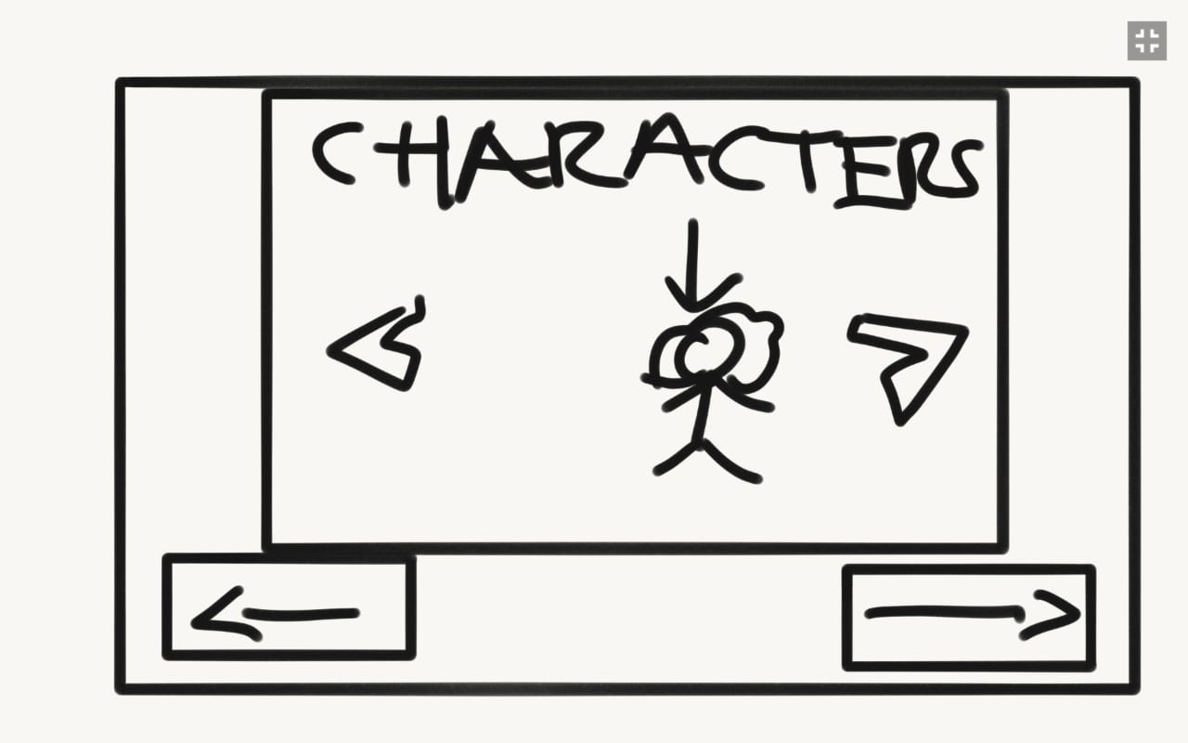

How do you plan to make your game engaging?

We are going to make it in p5 editor. With the help p5play.js we can create sprites, interesting animations, different backgrounds and the game is totally fun and engaging.